Aurelia Henry Reinhardt Residence rooms
$65/night
Aurelia Henry Reinhardt (AHR) residence rooms are single “dorm” rooms close to Mills dining options and surronded by beautiful vegetation. There are 19 rooms available in the building and 7 bathrooms. Rooms come with bed linens and towels. There is also a full kitchen with limited amount of basic kitchen supplies, and a lovely sitting and working area.
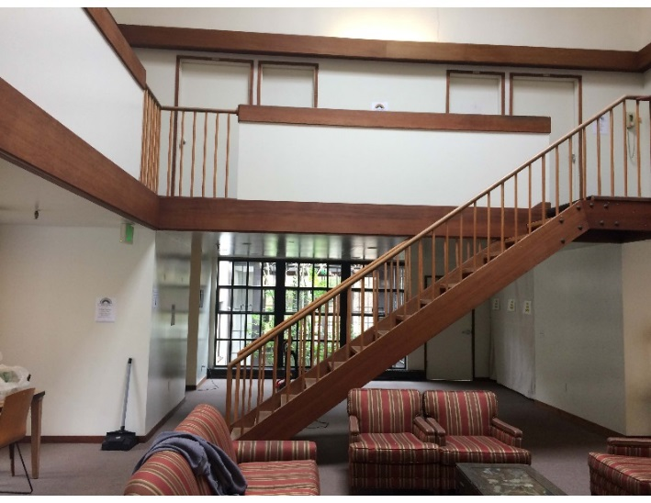  Sitting Area | 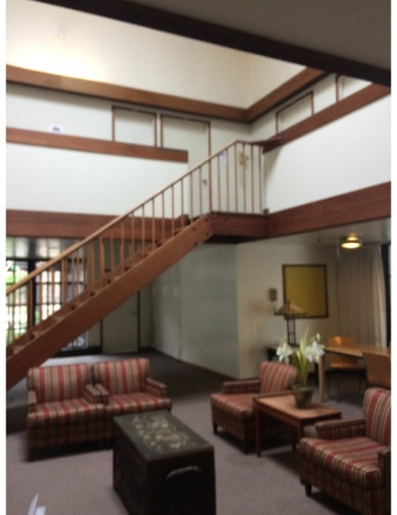  Sitting Area
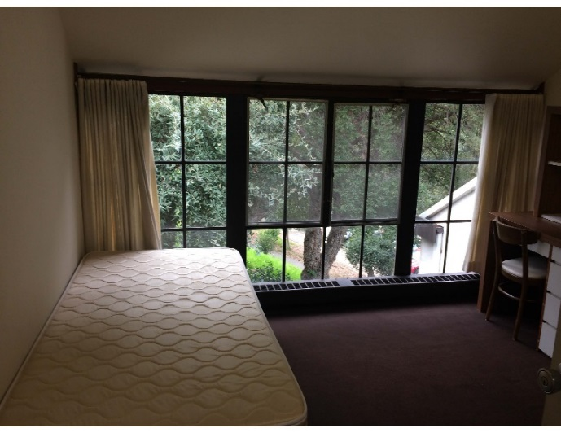  Room | 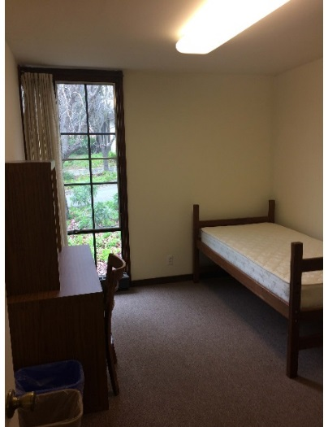  Room
Contact:
To book a room email a request to guestroom@mills.edu or call 510.430.2127 to check availability. Please mention you are part of the SE 17 Conference

